SUMMARY REPORT OF EXPERT TALK ON “Role of Physiotherapist in Sports” by Dr. Mohindarsingh Varma
(MPT-Musculoskeletal and Sports Science, Sports Physiotherapist, Sports Authority of Gujarat)

School of Physiotherapy, RK University, Organized an expert talk on “Role of Physiotherapist in Sports” on 3rd February,2020 for students of 6th Semester BPT, School of Physiotherapy,RK University.

Resource Person for an expert talk was Dr. Mohindarsingh Varma (MPT- Musculoskeletal and Sports Sciences, who is Sports physiotherapist in DLSS under Sports Authority of Gujarat.
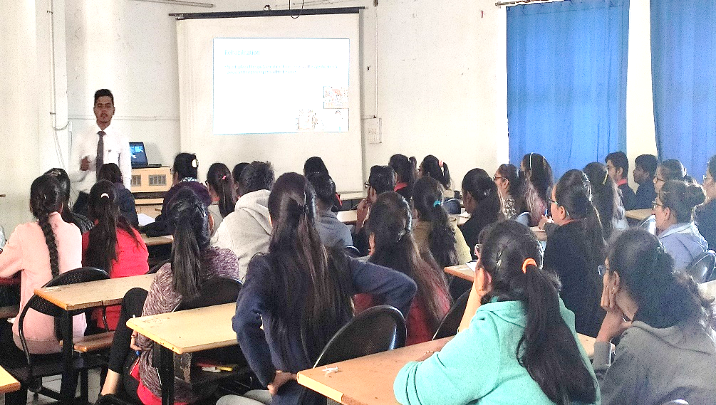
An expert talk was held at Lecture hall-5, RK University from 11:00 AM to 12:00 PM, around 90 students and 1 faculty of SOPT participated in this seminar. Key points to be learnt from the seminar were: Scope of sports physiotherapy at national and international level, Role of Physiotherapist in Sports, Future of physiotherapy in India, Followed by questions and answers with students.

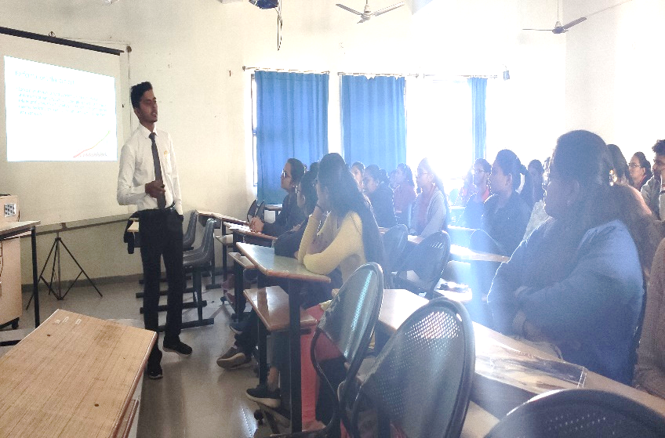

After an expert talk Dr. Ankita Chauhan facilitate the Dr. Mohindarsingh Varma.

The lecture has proven to be very inspiring and informative for students.

