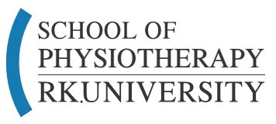
Summary Report on –
HANDS ON WORKSHOP ON
MUSCLE ENERGY TECHNIQUE (MET) AND MYOFASCIAL RELEASE TECHNIQUE(MFR)

Resource person: Dr. Ankur Parekh
Organized By: Dr.Krupa Raithatha
Participants: Dr.Krupa Raithatha, PG Students

School of Physiotherapy, RK University, Organized a hands on workshop on Muscle energy technique(MET) and Myofascial Release Technique (MFR) at RK Physiotherapy and research Rehabilitation Center, Rajkot on 21st January 2018 for PG Students.

Eighteen PG students and one Faculty of SOPT participated in this workshop.

Topic covered in 8 hours of workshop are as follows-

# | TOPICS | DURATION
1 | Introduction and explanation of myofascial pain, myofascial trigger points and muscle energy including its etiology, pathophysiology and clinical implications. | 1 hr.
2 | Assessment and diagnostic criteria for myofascial pain and trigger points, including how to differentiate myofascial pain and trigger points from other clinical conditions such as fibromyalgia, chronic pain syndrome, Fibrositis etc. | 1.30 hr.
4 | Principles, practise & Hands on demonstration and application of techniques that help resolve myofascial pain and trigger points at the earliest. | 3.30 hr
4 | Muscle energy techniques Hands on demonstration | 2 hr.

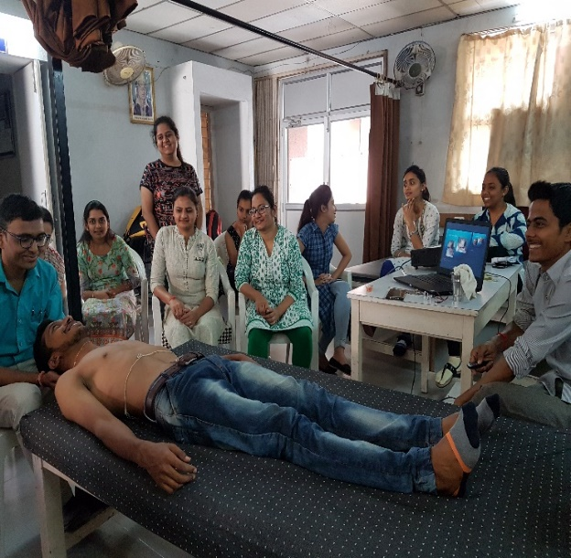
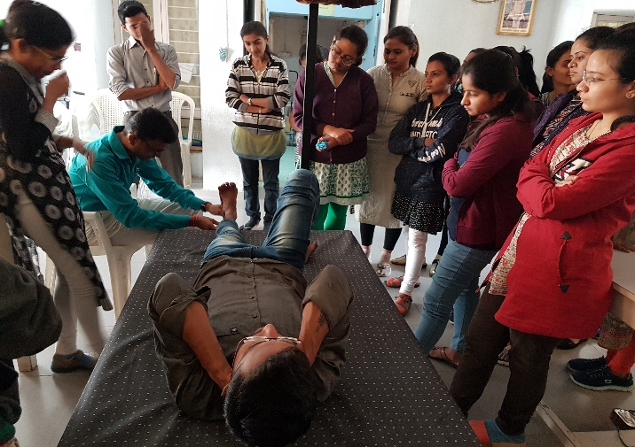

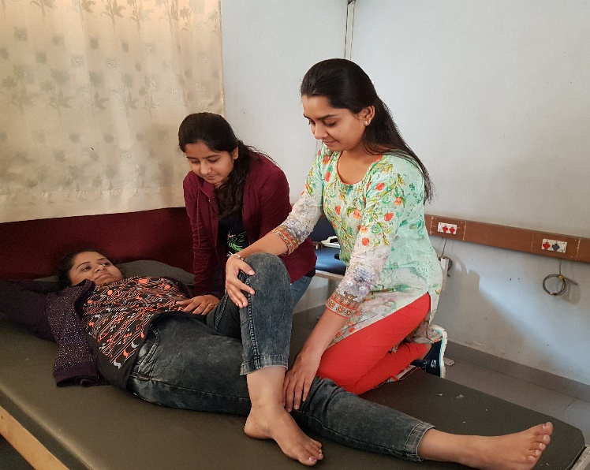
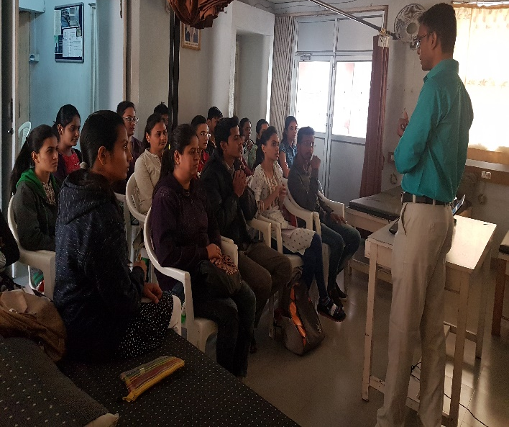

After completion of workshop, Students were given certificates by Dr. Ankur Parekh.
